|  |  |
| --- | --- |
|  | 8049 |

|  |  |  |
| --- | --- | --- |
|  |  |  |

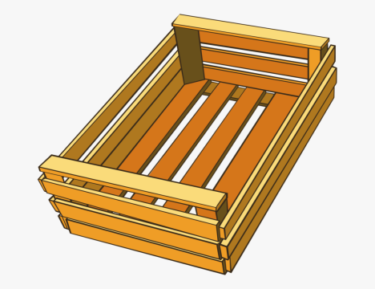

|  |  |  |
| --- | --- | --- |
|  |  |  |

|  |  |  |  |
| --- | --- | --- | --- |
|  |  |  |  |

|  |  |  |  |
| --- | --- | --- | --- |
|  |  |  |  |



|  |  |  |  |  |  |
| --- | --- | --- | --- | --- | --- |
|  |  |  |  |  |  |

|  |  |  |
| --- | --- | --- |
|  |  | marine-recreation-25325504 |

|  |  |  |  |
| --- | --- | --- | --- |
|  |  |  |  |

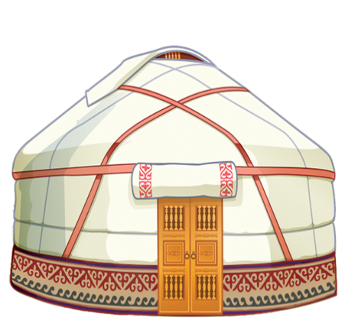

|  |  |  |
| --- | --- | --- |
|  |  |  |

|  |  |  |  |
| --- | --- | --- | --- |
|  |  |  |  |

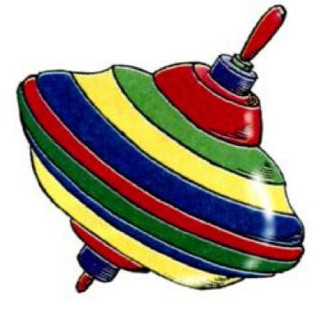

|  |  |
| --- | --- |
|  |  |

|  |  |  |
| --- | --- | --- |
|  |  |  |

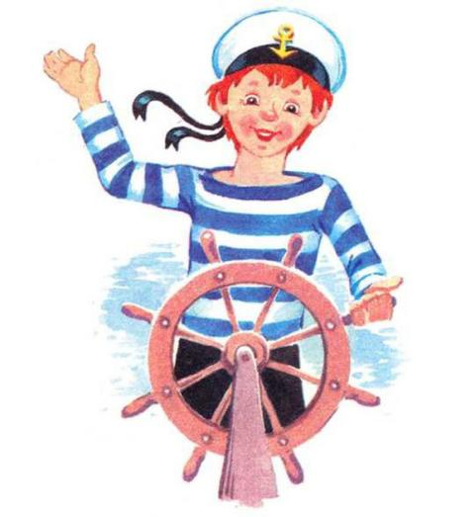

|  |  |  |
| --- | --- | --- |
|  |  |  |

|  |  |  |  |
| --- | --- | --- | --- |
|  |  |  |  |

|  |  |
| --- | --- |
|  | ezhik2 |

|  |  |
| --- | --- |
|  |  |

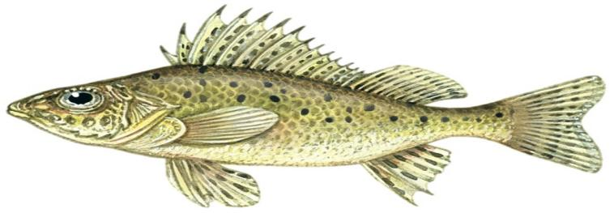

|  |  |  |
| --- | --- | --- |
|  |  |  |

|  |  |  |
| --- | --- | --- |
|  |  |  |

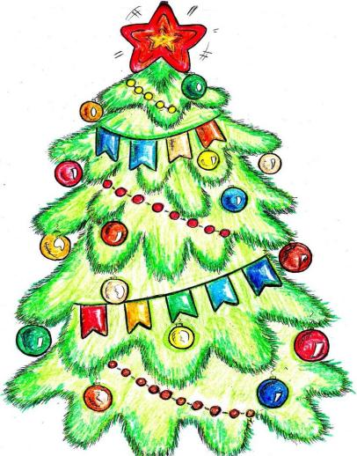

|  |  |  |
| --- | --- | --- |
|  |  |  |

|  |  |  |  |
| --- | --- | --- | --- |
|  |  |  |  |

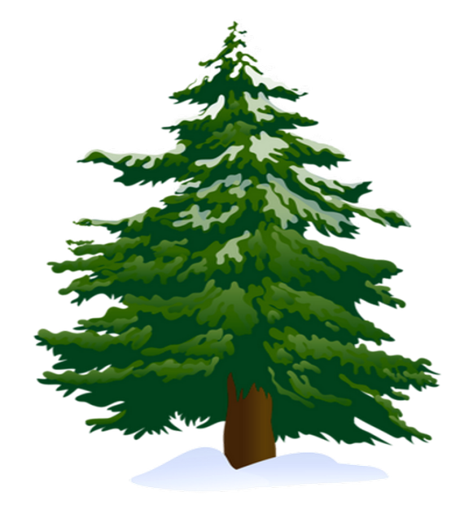

|  |  |
| --- | --- |
|  |  |

|  |  |  |
| --- | --- | --- |
|  |  |  |
|  | |  | | 9e71e1fcd535d032f85b2c41dbe5d528--coreldraw-cricut-design |

|  |  |  |  |
| --- | --- | --- | --- |
|  |  |  |  |

|  |  |
| --- | --- |
|  | Ежиха-с-ежатами-картинки-и-рисунки-023 |

|  |  |  |
| --- | --- | --- |
|  |  |  |

|  |  |  |  |
| --- | --- | --- | --- |
|  |  |  |  |

|  |  |  |  |  |  |  |
| --- | --- | --- | --- | --- | --- | --- |
|  |  |  |  |  |  |  |

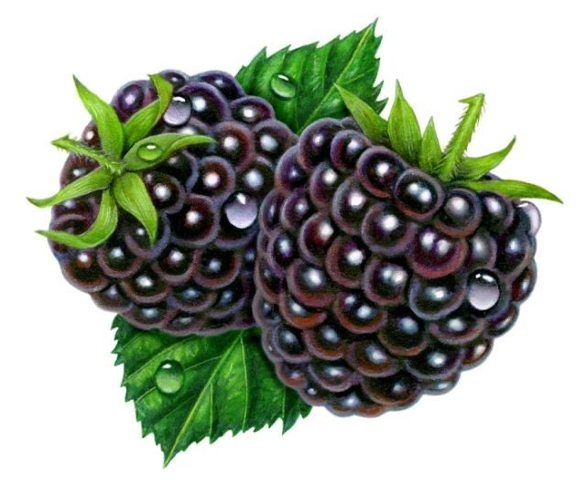

|  |  |  |
| --- | --- | --- |
|  |  | ewxR3uz-IVFKiR1oVzdTSTvWNQR3W9mWv-xecS0Kk3FXj-JZsWl_Snyfqn6y_14oEe0Ne0Quyd_SqKpNWEXHTR8V |

|  |  |  |  |
| --- | --- | --- | --- |
|  |  |  |  |



|  |  |  |
| --- | --- | --- |
|  |  |  |

|  |  |  |  |  |
| --- | --- | --- | --- | --- |
|  |  |  |  |  |

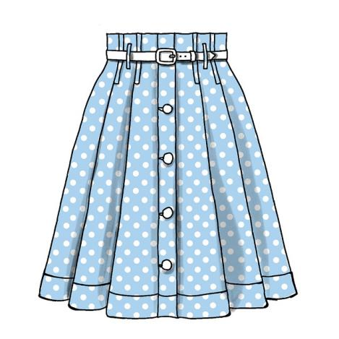

|  |  |  |
| --- | --- | --- |
|  |  |  |

|  |  |  |  |
| --- | --- | --- | --- |
|  |  |  |  |



|  |  |  |
| --- | --- | --- |
|  |  |  |

|  |  |  |  |
| --- | --- | --- | --- |
|  |  |  |  |

|  |  |
| --- | --- |
|  | 9d401719584b69bf786aaf1410c8ca2e |

|  |  |  |
| --- | --- | --- |
|  |  |  |

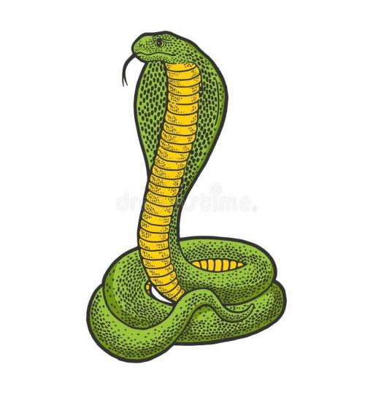

|  |  |  |
| --- | --- | --- |
|  |  |  |

|  |  |  |  |
| --- | --- | --- | --- |
|  |  |  |  |

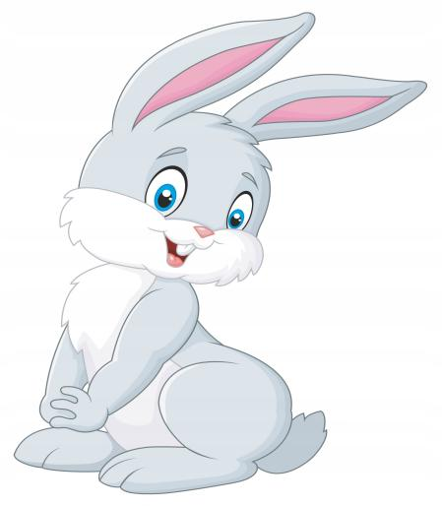

|  |  |  |
| --- | --- | --- |
|  |  |  |

|  |  |  |  |
| --- | --- | --- | --- |
|  |  |  |  |

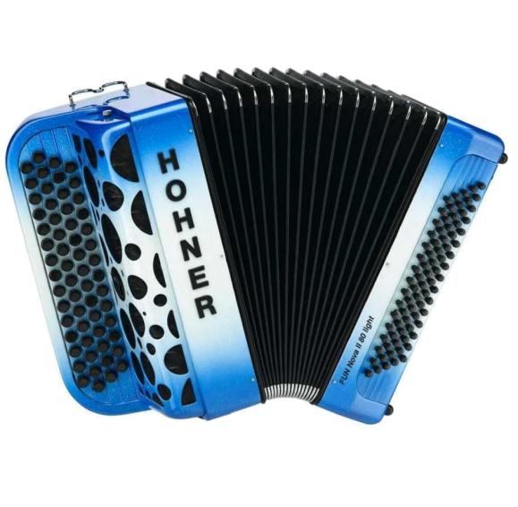

|  |  |  |
| --- | --- | --- |
|  |  |  |

|  |  |  |  |
| --- | --- | --- | --- |
|  |  |  |  |

|  |  |  |
| --- | --- | --- |
|  |  | large_e55749e8-6edf-44a7-af64-20544f8c6133 |

|  |  |  |  |
| --- | --- | --- | --- |
|  |  |  |  |

|  |  |  |  |
| --- | --- | --- | --- |
|  |  |  |  |

|  |  |  |  |  |
| --- | --- | --- | --- | --- |
|  |  |  |  |  |

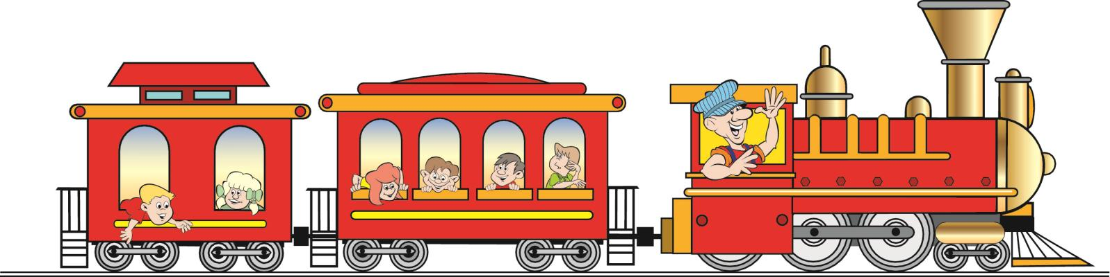

|  |  |  |  |
| --- | --- | --- | --- |
|  |  |  | b6a656a386ce4ea9c6ad86d0194587cd |

|  |  |  |  |  |  |
| --- | --- | --- | --- | --- | --- |
|  |  |  |  |  |  |

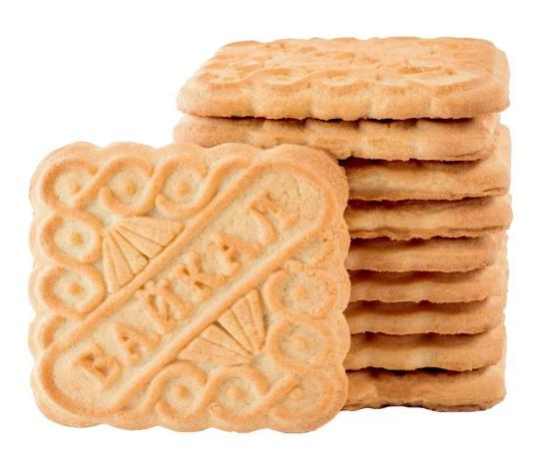

|  |  |  |  |
| --- | --- | --- | --- |
|  |  |  |  |

|  |  |  |  |  |  |  |
| --- | --- | --- | --- | --- | --- | --- |
|  |  |  |  |  |  |  |

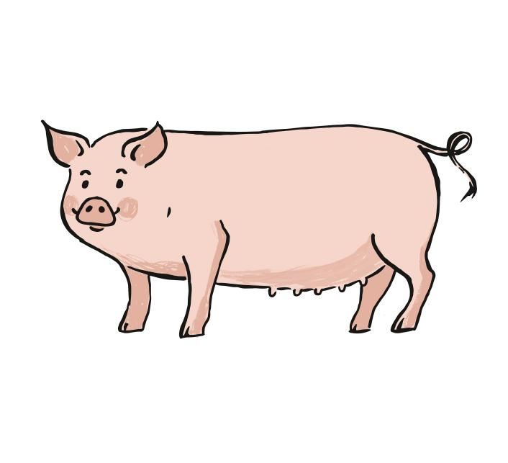

|  |  |  |  |
| --- | --- | --- | --- |
|  |  |  |  |

|  |  |  |  |  |  |
| --- | --- | --- | --- | --- | --- |
|  |  |  |  |  |  |

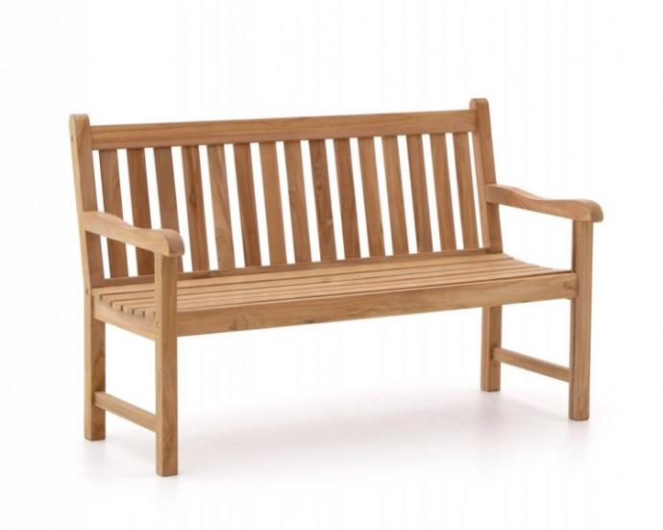

|  |  |  |  |
| --- | --- | --- | --- |
|  |  |  |  |

|  |  |  |  |  |  |  |  |  |
| --- | --- | --- | --- | --- | --- | --- | --- | --- |
|  |  | |  |  | |  |  | |
|  | |  | | | pngtree-spear-02h84049eps-battle-brown-conflict-png-image_8175835 | | |

|  |  |  |  |  |
| --- | --- | --- | --- | --- |
|  |  |  |  |  |

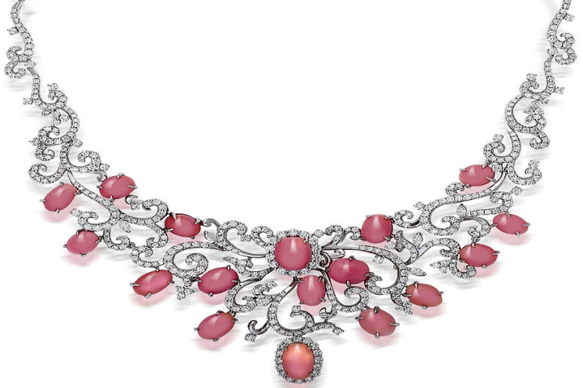

|  |  |  |
| --- | --- | --- |
|  |  |  |

|  |  |  |  |  |
| --- | --- | --- | --- | --- |
|  |  |  |  |  |

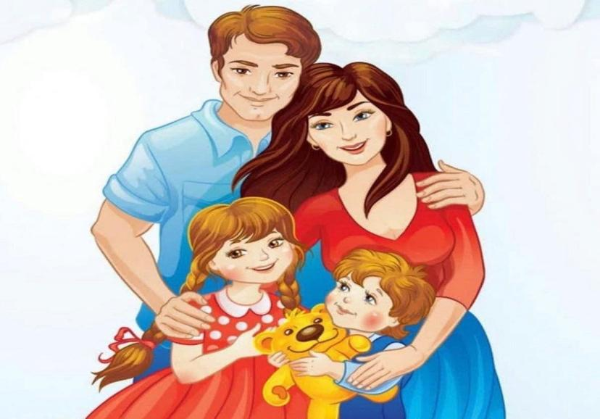

|  |  |  |
| --- | --- | --- |
|  |  |  |

|  |  |  |  |  |
| --- | --- | --- | --- | --- |
|  |  |  |  |  |

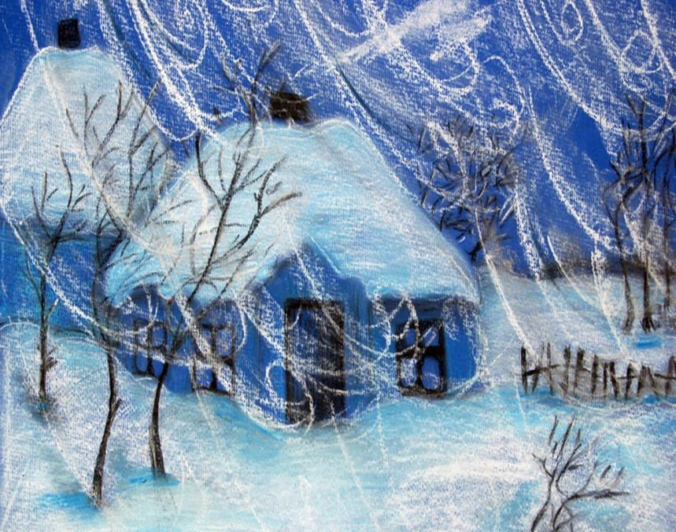

|  |  |  |
| --- | --- | --- |
|  |  |  |

|  |  |  |  |  |
| --- | --- | --- | --- | --- |
|  |  |  |  |  |

|  |  |  |  |
| --- | --- | --- | --- |
|  |  |  | 5ea372b485e76a02497d82fe0f407e9d |

|  |  |  |  |  |  |  |
| --- | --- | --- | --- | --- | --- | --- |
|  |  |  |  |  |  |  |



        
        
        

            
            
            

          
          
          

  
  
  

                
                
                

