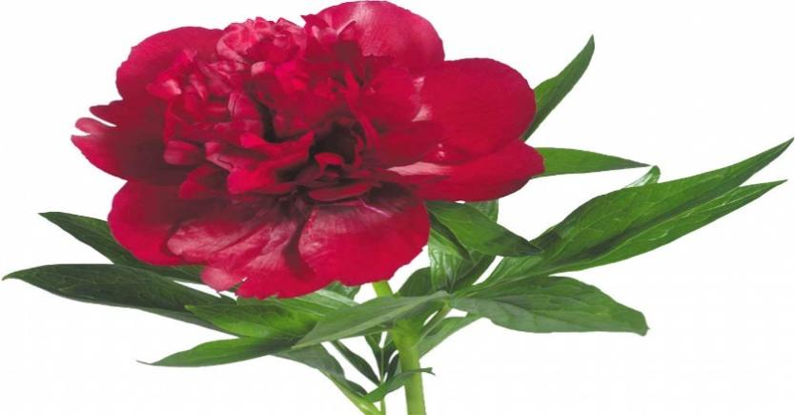

|  |  |  |  |
| --- | --- | --- | --- |
|  |  |  |  |

|  |  |  |
| --- | --- | --- |
|  |  |  |

______________________________________________________________________________________________

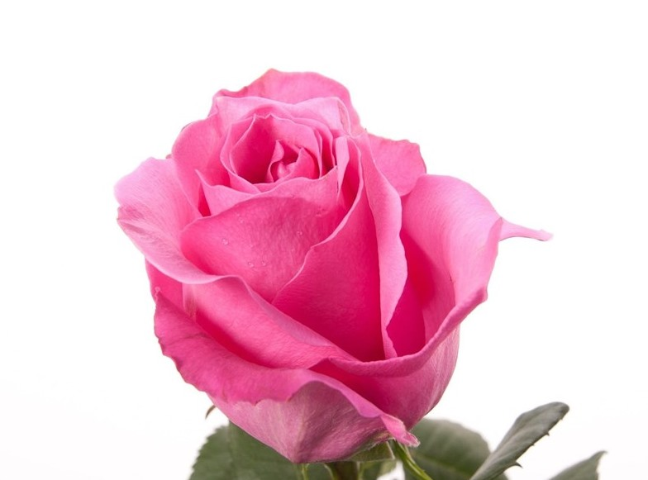

|  |  |  |  |
| --- | --- | --- | --- |
|  |  |  |  |

|  |  |
| --- | --- |
|  |  |

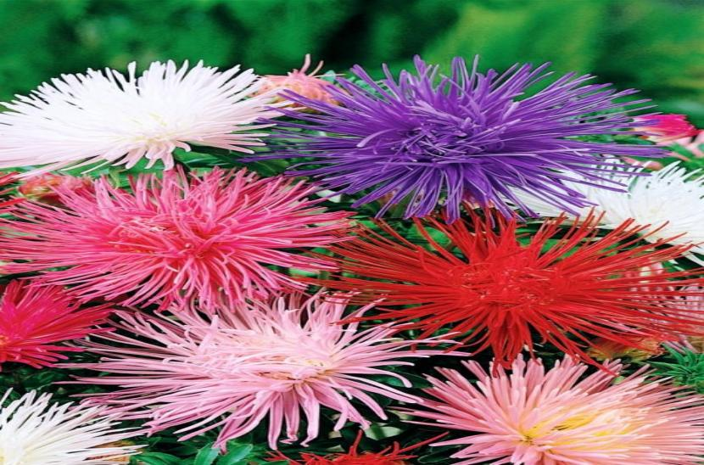 

|  |  |  |  |  |
| --- | --- | --- | --- | --- |
|  |  |  |  |  |

|  |  |  |  |
| --- | --- | --- | --- |
|  |  |  |  |

_______________________________________________________________________________________________

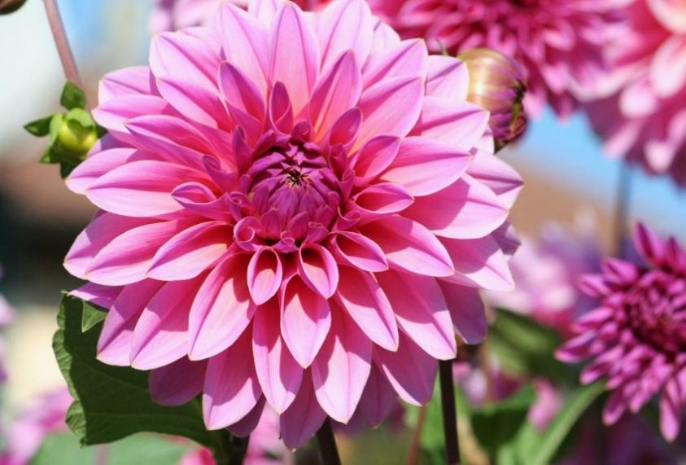

|  |  |  |  |  |  |  |
| --- | --- | --- | --- | --- | --- | --- |
|  |  |  |  |  |  |  |

|  |  |  |  |  |
| --- | --- | --- | --- | --- |
|  |  |  |  |  |



|  |  |  |  |  |  |  |
| --- | --- | --- | --- | --- | --- | --- |
|  |  |  |  |  |  |  |

|  |  |  |  |
| --- | --- | --- | --- |
|  |  |  |  |

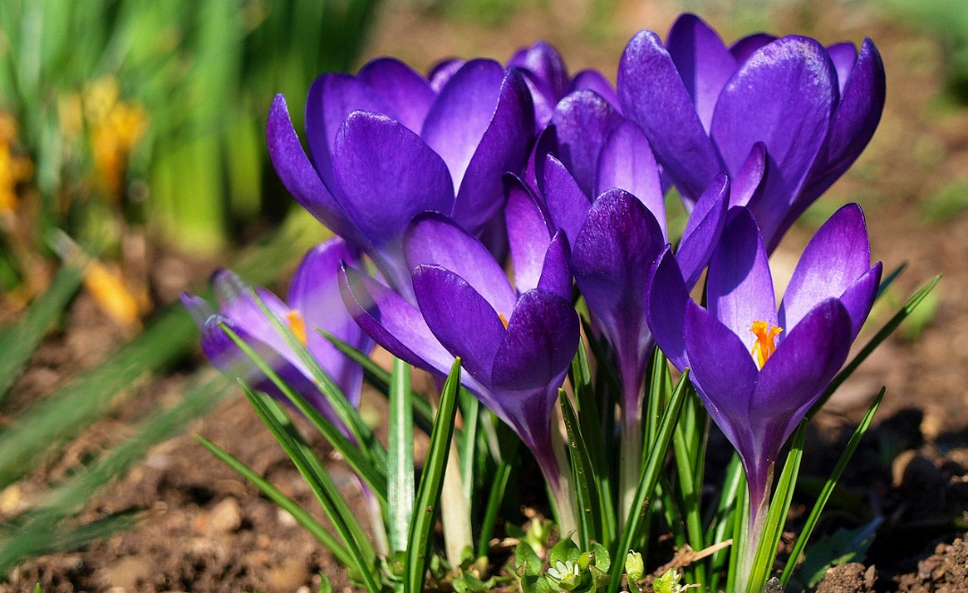

|  |  |  |  |  |  |  |
| --- | --- | --- | --- | --- | --- | --- |
|  |  |  |  |  |  |  |

|  |  |  |  |
| --- | --- | --- | --- |
|  |  |  |  |

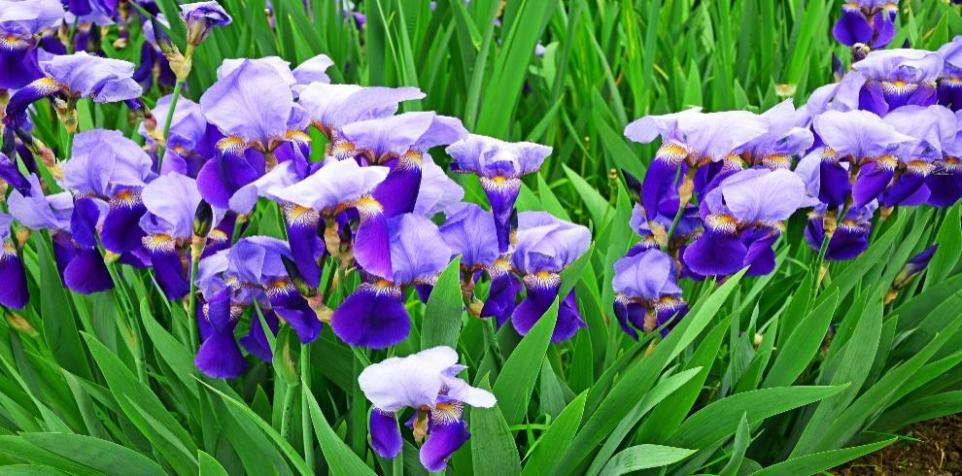

|  |  |  |  |  |
| --- | --- | --- | --- | --- |
|  |  |  |  |  |

|  |  |  |
| --- | --- | --- |
|  |  |  |



|  |  |  |  |  |  |  |
| --- | --- | --- | --- | --- | --- | --- |
|  |  |  |  |  |  |  |

|  |  |  |  |
| --- | --- | --- | --- |
|  |  |  |  |



|  |  |  |  |  |  |  |
| --- | --- | --- | --- | --- | --- | --- |
|  |  |  |  |  |  |  |

|  |  |  |  |
| --- | --- | --- | --- |
|  |  |  |  |



|  |  |  |  |  |  |  |  |
| --- | --- | --- | --- | --- | --- | --- | --- |
|  |  |  |  |  |  |  |  |

|  |  |  |  |  |
| --- | --- | --- | --- | --- |
|  |  |  |  |  |

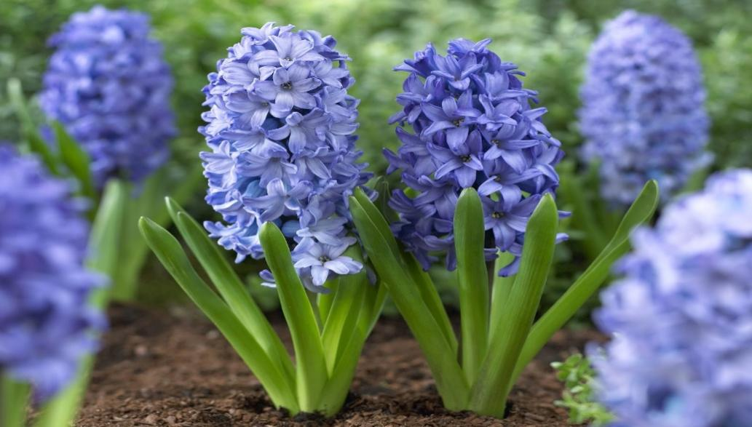

|  |  |  |  |  |  |  |  |
| --- | --- | --- | --- | --- | --- | --- | --- |
|  |  |  |  |  |  |  |  |

|  |  |  |  |  |
| --- | --- | --- | --- | --- |
|  |  |  |  |  |



|  |  |  |  |  |  |  |
| --- | --- | --- | --- | --- | --- | --- |
|  |  |  |  |  |  |  |

|  |  |  |  |
| --- | --- | --- | --- |
|  |  |  |  |



|  |  |  |  |  |  |  |
| --- | --- | --- | --- | --- | --- | --- |
|  |  |  |  |  |  |  |

|  |  |  |  |
| --- | --- | --- | --- |
|  |  |  |  |

_______________________________________________________________________________________________



|  |  |  |  |  |
| --- | --- | --- | --- | --- |
|  |  |  |  |  |

|  |  |  |
| --- | --- | --- |
|  |  |  |



|  |  |  |  |
| --- | --- | --- | --- |
|  |  |  |  |

|  |  |
| --- | --- |
|  |  |

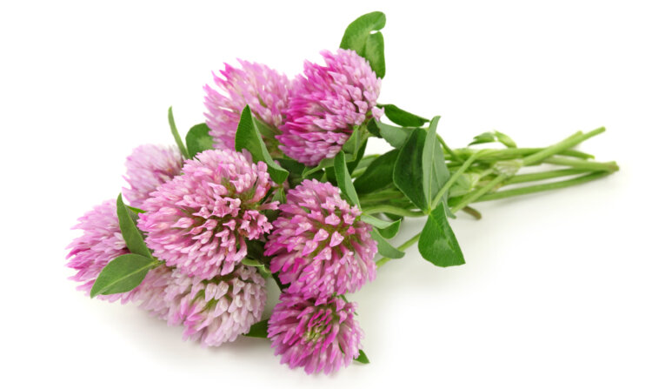

|  |  |  |  |  |  |
| --- | --- | --- | --- | --- | --- |
|  |  |  |  |  |  |

|  |  |  |  |
| --- | --- | --- | --- |
|  |  |  |  |

ИРИСЫ

ЛАНДЫШИ

ПИОН

РОЗА

АСТРЫ

ГЕОРГИН

ГЕРБЕРЫ

КРОКУСЫ

ТЮЛЬПАН

НАРЦИССЫ

ГИАЦИНТЫ

РОМАШКА

ВАСИЛЁК

ЛЮТИК

МАКИ

КЛЕВЕР